Angels Calling Tour
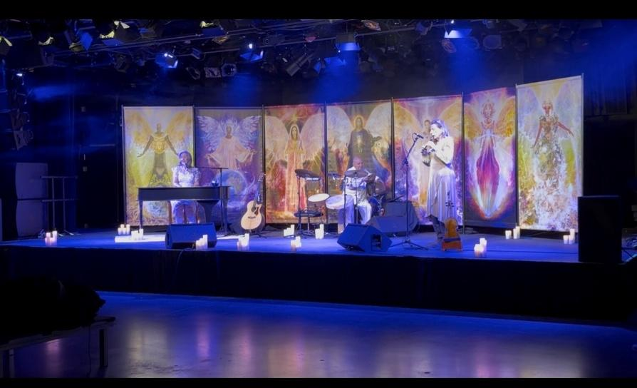
The Angels Calling Tour is a 75-minute immersive experience featuring Mary Verdi’s original music which has a distinctive angelic thread throughout. The trio is surrounded by a 28-foot Angel Installation creating a multi-sensory experience. Seven Angel Messages are featured throughout the concert. This is not a religious concert, Angels are Universal.

The fLIGHT Trio:
Mary Verdi Creator, Songwriter, Vocals, Keyboard, Guitar
Eileen Markland Violin, Viola, Penney Whistle
Brian Melick Hand Percussionist

Angels Calling Art Installation
Co-created by Calista/Calista Ascension® from Scotland and a world peace activist/visual artist, Marie Fourzali from Lebanon

Biographies:
Mary Verdi (Vocals, Keyboard, Guitar, Songwriter) is based in the Berkshires. She first stepped onto the stage at the age of 3 in her father’s opera and musical theatre productions in the Midwest. She began her professional path in Nashville as Reba McEntire’s assistant, after graduating from Belmont University. Mary traveled with Kings Productions as a Singer/Dancer through her 20’s and began writing songs at the age of 28. She has 7 CDs that have culminated into 1.6 million YouTube views. She has appeared on EWTN, The Pentagon, Fenway Stadium (her sons’ favorite) and has sung duets with Livingston Taylor & Larry Gaitlin. Mary has been certified as a Sacred Prayer Practitioner and holds two certifications in Angel Healing®. www.maryverdi.com
Eileen Markland (Violin/Viola/Penney Whistle) is a versatile performer, recording artist, and dedicated music educator, known for her extensive experience and active involvement in a wide array of music projects. Eileen has performed with a diverse range of artists, including the Berkshire Symphony, Albany Symphony, Binghamton Symphony, Kilashandra, Misty Blues, The Jolly Ranchers, Ravin’ Mavens, and the Berkshire Trio. Eileen is celebrated for her fearless stage presence, remarkable versatility, beautiful tone, and soulful interpretations. With a focus on creating a sense of peace and inclusion through her music, she believes in the transformative power of music to bring people together. Eileen and Mary have been collaborating for over 18 years.

Brian Melick (Hand Percussionist) is a Musician, Educator, Author and Composer. Brian has been performing since the early age of 13. Featured recording artist on over 500 commercially released recordings to date on independent as well as major labels highlighted by his seven solo projects. Many are sound libraries placed with Universal, MGM, Columbia, Fox, Discover, TLC, and Disney.
Brian built and performs on the first ever Lego Drum Set which was featured in Modern Drummer and is now in the Percussive Arts Society’s international museum, Rhythm Discovery Center! Brian maintains a very diverse schedule throughout the US, Canada and most recently Ghana, West Africa including producing several of his own 4-part concert series highlighting cultural diversity. This is Brian’s 1st tour with Mary. www.uduboy.com
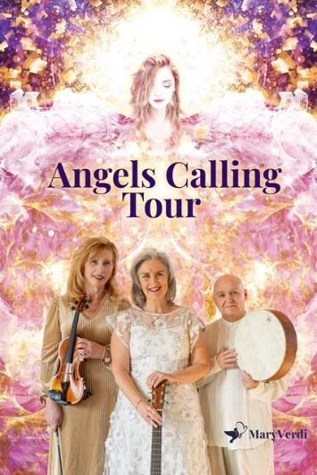
Mary Verdi mary@maryverdi.com
413.841.1140
www.maryverdi.com
www.maryverdi.com/press
https://facebook.com/MaryVerdiMusician
https://www.instagram.com/MaryVerdi
https://maryverdi.com/angels-calling/ for latest music

Verdi Music
Mary Verdi

Discography: Ocean for Travel (’04), Christmas in the Berkshires (’06), Precious Love (’08), Precious Moments (’11), Flight (’18), Abundant Joy (’22), EP Angels Calling, Just for a Moment, We are Here (’26)

Kings Productions Touring Shows 8 years (Touring Performer)
Colonial Theatre (BTG) 10 years -Christmas in the Berkshires with Mary Verdi (Performer/Director)
Pentagon performed her penned patriotic song, ‘Here at Home’
Past Tours for Cd Releases
Fenway sang National Anthem
Performed Duets with Larry Gatlin and Liv Taylor
1.6 million Views/Listens on YouTube
Belmont University Alumni
Assistant to Reba McEntire 1990
TV Appearances: Good Morning Mexico, EWTN, Catholic Tv Boston, Reel to Reel Program, PCTV

Mary Verdi’s childhood training was under the direction of her father, the late William B. Handley, a symphony conductor who introduced Mary to many operas/musicals creating her love of the stage. Mary wrote a one-woman play/musical about her life and the angelic thread throughout her music. This current tour, Angels Calling, was created from that play.

